The 8th Asian Symposium on Microbial Ecology
ASME
Taipei, Taiwan
Sep. 30-Oct. 2, 2016
(Circular 3)

Venue
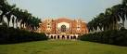
Center for Condensed Matter Sciences, National Taiwan University, No. 1, Sec. 4, Roosevelt Road, Taipei 10617, Taiwan
National Taiwan University

Organized by
Taiwan Society of Microbial Ecology (TSME)
The Microbiological Society of Korea (MSK)
Japanese Society of Microbial Ecology (JSME)

International organizing committee
Chang-Ping Yu, National Taiwan University, Taiwan
Shir-Ly Huang, National Yang-Ming University, Taiwan
Pi-Han Wang, Tunghai University, Taiwan
Woojun Park, Korea University, Korea
Jong-Chan Chae, Chonbuk National University, Korea
Che Ok Jeon, Chung-Ang University, Korea
Natsuko Hamamura, Kyushu University, Japan
Koji Hamasaki, The University of Tokyo, Japan
Mio Takeuchi, National Institute of Advanced Industrial Science and Technology, Japan
Jidong Gu, The University of Hong Kong, Hong Kong
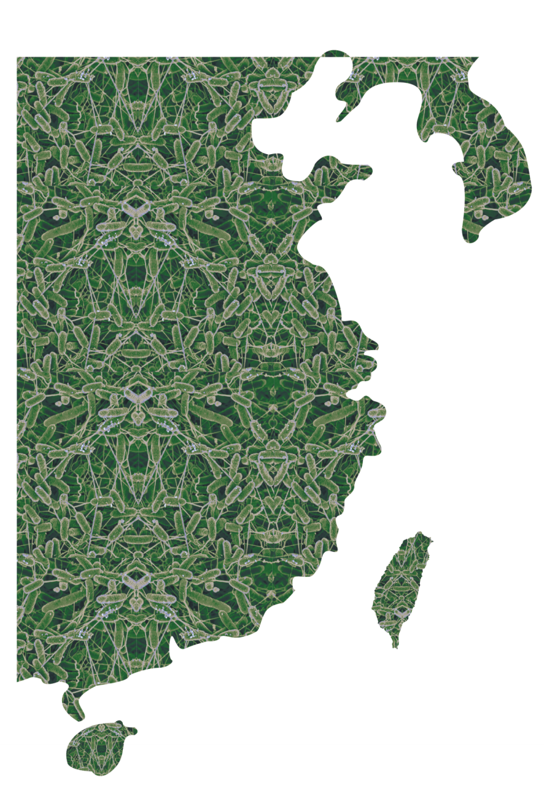
Jianzhong He, National University of Singapore, Singapore
☉

Local organizer
National Taiwan University
National Yang-Ming University
National Central University
Academia Sinica
National Pingtung University of Science & Technology
Tunghai University

Local organizing committee
Chair:
Shir-Ly Huang, National Yang-Ming University, Taiwan
Board members:
Chang-Ping Yu, National Taiwan University, Taiwan
Hsin-Hsin Tung, National Taiwan University, Taiwan
Chi-Te Liu, National Taiwan University, Taiwan
Pi-Han Wang, Tunghai University, Taiwan
Hsion-Wen Kuo, Tunghai University, Taiwan
Jyh-Yih Leu, Fu Jen Catholic University, Taiwan
Chu-Ching Lin, National Central University, Taiwan
Roland Kirschner, National Central University, Taiwan
Jer-Horng Wu, National Cheng Kung University, Taiwan
Juei-Yu Chiu, National Pingtung University of Science & Technology
Chun-Yao Chen, Tzu Chi University, Taiwan
Yin-Ru Chiang, Academia Sinica, Taiwan

Local sponsor
Taipei City Government
YOURGENE Bioscience, Taiwan
UTRUST Web-Based Solution, Taiwan

Executive advisors:
Shiu-Mei Liu, National Taiwan Ocean University, Taiwan
Sang-Jin Kim, National Marine Biodiversity Institute of Korea, Korea
Kazuhiro Kogure, The University of Tokyo, Japan

Access
NTU：https://visitorcenter.cloud.ntu.edu.tw/eng/p5-transportation.php
Taiwan Taoyuan International Airport：http://www.taoyuan-airport.com/english/Index/
Taipei Songshan Airport：http://www.tsa.gov.tw/tsa/en/home.aspx
Taipei Metro Service: http://english.metro.taipei/

Note:
Songshan Airport is within Taipei city. You may use Taipei Rapid Transit to go around Taipei. You may also get Taxi everywhere in Taipei. Taoyuan International Airport is more than 30 km away from Taipei. You may take bus to reach Taipei city. No subway system is available from Taoyuan International Airport to Taipei city yet.

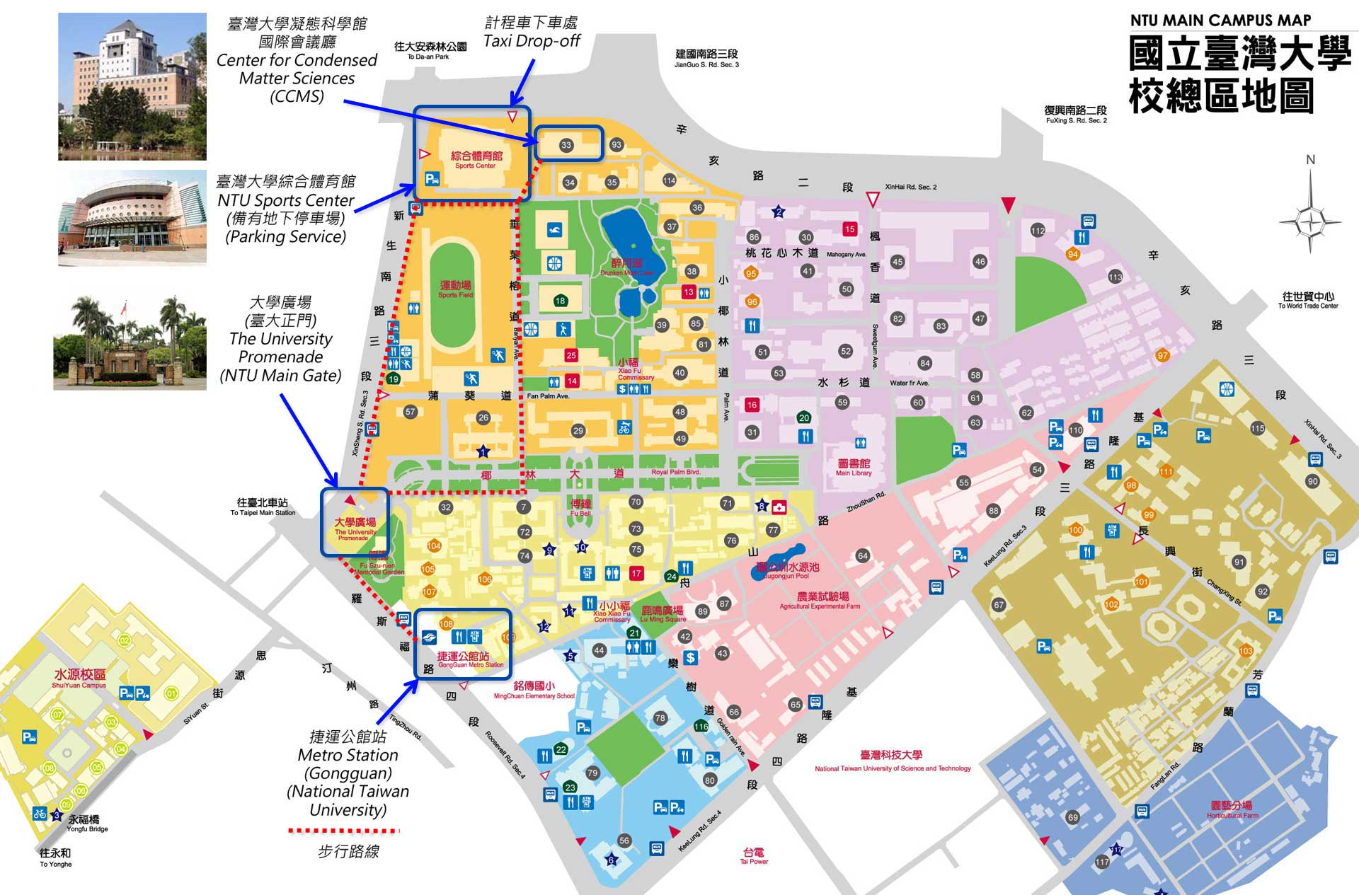

Language
English

Homepage
http://asme.enve.ntu.edu.tw
(Website is mobile phone friendly)

Registration and Abstract Submission
Registration fee for regular participant 5,000 TWD (including 1 banquet and 1 lunch)
Registration fee for student (with student ID, excluding research assistant, postdoc) 2,000 TWD (including 1 banquet and 1 lunch)
Registration fee will be collected on-site at the registration desk of the conference venue (Please prepare New Taiwan dollar and credit card payment is not available).

For on-line registration, please go to http://asme.enve.ntu.edu.tw
Or simply send the registration form and abstract to Mr. Chung-Yu Guan (d03541001@ntu.edu.tw)

Note:
1. All participants are welcome to attend all invited talks in the Annual Meeting of TSME on 9/30 (For the Annual Meeting of TSME, all talks in the table shaded with “green” are in Chinese except for Round Table Discussion with Prof. Rebecca Parales and Prof. Jidong Gu).
2. For Taiwanese participants only attending the Annual Meeting of TSME on 9/30:
Registration fee for Regular participant 1,000 TWD (including 1 lunch)
Registration fee for Student (with student ID, excluding research assistant, postdoc) 500 TWD (including 1 lunch)

Poster Presentation
Please set up your poster on 9/30 and be in front of your poster during poster sessions. Poster award will be announced before closing ceremony.

Important Deadlines
Online registration: September 18, 2016
Abstract submission: September 18, 2016

Accommodation
There are many hotels to choose in Taipei city and their information is available online. Please reserve hotel rooms by visiting their websites.
Here are some nearby hotels:
Shangrila’s Far Eastern Plaza Hotel
http://www.shangri-la.com/taipei/fareasternplazashangrila/
Just Sleep
http://justsleep.com.tw/NTU/en
Taipei Fullerton Hotel-South
http://www.taipeifullerton.com.tw/south/en/
Dandy Hotel Daan Park Branch
http://www.dandyhotel.com.tw/D/en/
K Hotel Dunnan
http://dunnan.khotel.com.tw/en/index.aspx

Contact
Scientific information:
Prof. Chang-Ping Yu
Graduate Institute of Environmental Engineering
National Taiwan University
cpyu@ntu.edu.tw

Workshop logistics:
Mr. Chung-Yu Guan
Graduate Institute of Environmental Engineering
National Taiwan University
d03541001@ntu.edu.tw
Program
September 30th, Friday
Time | 1st Floor Lobby & Room 111 (Center for Condensed Matter Sciences, NTU)
8:30 | Annual Meeting of TSME (in Chinese)  Registration  (TSME board member voting: 8:30-12:30)
9:00-9:20 | Opening:  Prof. Cheng-Fang Lin, Director of the Graduate Institute of Environmental Engineering, National Taiwan University  Prof. Shir-Ly Huang, National Yang-Ming University, President of Taiwan Society of Microbial Ecology (Introduction of TSME)
9:20-10:00 | Invited speech 1  Convener:  Prof. Shir-Ly Huang, National Yang-Ming University  Speaker:  Prof. Chiu-Chung Young, Academician of Academia Sinica, National Chung Hsing University  Topic: 農業環境微生物之研究
10:00-10:30 | Invited speech 2  Convener:  Prof. Shir-Ly Huang, National Yang-Ming University  Speaker:  Prof. Chu-Ching Lin, National Central University  Topic: Probing the biogeochemical controls on the formation, uptake and accumulation of methylmercury in the paddy ecosystem
10:30-10:50 | Coffee Break
10:50-11:30 | Invited speech 3  Convener:  Prof. Pi-Han Wang, Tunghai University  Speaker:  Prof. Ying-Chieh Tsai, National Yang-Ming University  Topic: 菌腦腸軸及精神益生菌
11:30-12:00 | Invited speech 4  Convener:  Prof. Pi-Han Wang, Tunghai University  Speaker:  Prof. Chun-Yao Chen, Tzu Chi University  Topic: Succession of microbial community inside animal gut
12:00-12:30 | TSME member assembly
12:30-13:30 | Convener:  Prof. Hsion-Wen Kuo, Tunghai University  Lunch lecture Sponsored by Yourgene Bioscience  Topic: 次世代定序於環境微生物的發展及應用
13:30-14:00 | TSME board meeting
14:00-14:30 | Convener: Prof. Roland Kirschner, National Central University  Invited speech 5 Dr. Gwo Fang Yuan, Bioresource Collection and Research Center
14:30-16:00 | Convener: Prof. Shir-Ly Huang, National Taiwan University  Round Table Discussion: Scientific Writing for Journal Submission (in English)  Guest speakers:  Prof. Rebecca Parales, Applied and Environmental Microbiology Editor, Microbiology Editor, University of California-Davis  Prof. Jidong Gu, International Biodeterioration & Biodegradation Editor, The University of Hong Kong
14:30-18:00 | Asian symposium on Microbial Ecology  Registration  Poster and Company Exhibition (set up in 1st Floor Lobby)
15:00-17:00 | Young scientist meeting (Location: Room 104, Center for Condensed Matter Sciences, NTU)  Advisor: Dr. Yin-Ru Chiang, Academia Sinica, Taiwan  Student Organizer/Convener:  Yi-Lung Chen, Ph.D. candidate, Academia Sinica (Taiwan)  Hyun Jung Kim, Ph.D. student, Korea University (Korea)  Satoshi Hiraoka, Ph.D. student, The University of Tokyo (Japan)  Yohei Kumagai, Ph.D. student, The University of Tokyo (Japan)  Jiangwei Li, Ph.D. student, Chinese Academy of Sciences (China)  Agenda:  - Invited speech: Mr. Hiroyasu Watai, Kyoto University  Title: Citizen science contributes to global microbial ecology: the case of Ocean Sampling Day  - Group discussion  - Group presentation
17:30-18:30 | Poster Session (presentation) 1st Floor Lobby
19:00-21:00 | Welcome Reception (by invitation)  (Meet at 18:30 in the 1st Floor Lobby, Center for Condensed Matter Sciences, NTU)
19:30-21:00 | Young scientist party (Contact person: Yi-Lung Chen)  (Meet at 19:00 in the 1st Floor Lobby, Center for Condensed Matter Sciences, NTU)  Location: Hot Over Sky: stir-friend seafood  (No.154, Sec. 2, Fuxing S. Rd., Da’an Dist., Taipei City 106, Taiwan)

October 1st, Saturday
 | 2nd Floor International Conference Hall  (Room 204, Center for Condensed Matter Sciences, NTU) |  | 1st Floor Lobby
8:30 – 8:50 | Opening:  Prof. Pan-Chyr Yang, President of National Taiwan University  Prof. Shir-Ly Huang, National Yang-Ming University,  President of Taiwan Society of Microbial Ecology
8:50 – 9:30 | Plenary speech 1  Convener:  Prof. Shiu-Mei Liu, National Taiwan Ocean University (Taiwan)  Speaker:  Dr. Sen-Ling Tang, Academia Sinica (Taiwan)  Topic: Coral microbes: Ecological role of the bacteria Endozoicomonas in corals
9:30 – 10:50 | Session 1. Marine microbiology, 80 min  Organizer/ Convener:  Prof. Hong-Thih Lai, National Chiayi University (Taiwan)  Prof. Koji Hamasaki, The University of Tokyo (Japan)  Speakers:  Prof. Jidong Gu, The University of Hong Kong (Hong Kong)  Topic: (to be announced)  Prof. Akito Taniguchi, Kindai University (Japan)  Topic: Seasonal variation in community structures of actively growing bacteria in the aquaculture environment  Prof. Pei-Ling Wang, National Taiwan University (Taiwan)  Topic: Probing aerobic methanotrophs in offshore southwestern Taiwan  Dr. Anyi Hu, Chinese Academy of Sciences (China)  Topic: Spatial and temporal dynamics of microbial communities in a human-perturbed estuary of China
10:50 – 11:20 | Coffee Break & Group photo
11:20 –12:00 | Session 2. Life in extreme environments, 40 min  Organizer/ Convener:  Prof. Li-Hung Lin, National Taiwan University (Taiwan)  Prof. Woojun Park, Korea University (Korea)  Speakers:  Prof. Sayaka Mino, Hokkaido University (Japan)  Topic: Limits to dispersal in a cosmopolitan chemolithoautotroph living in deep-sea hydrothermal vents  Prof. Li-Hung Lin, National Taiwan University (Taiwan)  Topic: Microbial methane cycling in terrestrial mud volcanoes
12:00 – 13:30 | Lunch | Women Scientists Round Table  (Location: Room 111)  Organizer: Prof. Pi-Han Wang (Taiwan)  Prof. Song-Ih Han (Korea)  Prof. Naoko Yoshida (Japan)  Guest speakers:  Prof. Kung-Hui Chu (USA)  Prof. Jianzhong He (Singapore) | Poster session  (presentation)
13:30 – 14:50 | Session 3. Ecology and evolution of host-associated microbes, 80 min  Organizer/ Convener:  Prof. Chun-Yao Chen, Tzu Chi University (Taiwan)  Prof. Jin-Woo Bae, Kyung Hee University (Korea)  Speakers:  Prof. Patrick Lee, Hong Kong City University (Hong Kong)  Topic: Skin bacterial and fungal communities of urban Chinese individuals in Hong Kong  Prof. Jin-Woo Bae, Kyung Hee University (Korea)  Topic: Impact of drugs on host health via gut bacterial and viral community change  Dr. Hideomi Itoh, Bioproduction Research Institute AIST (Japan)  Topic: Soil microbiota is the key to the life and death of pest insects  Dr. Chih-Horng Kuo, Academia Sinica (Taiwan)  Topic: Diverse patterns of genome evolution in arthropod-symbiotic Spiroplasma
14:50 – 15:05 | Coffee break
15:05 – 15:45 | Plenary speech 2  Convener:  Prof. Hsin-Hsin Tung, National Taiwan University (Taiwan)  Speaker:  Prof. Pi-Han Wang, Tunghai University (Taiwan)  Topic: Fungal stories in forests: Scaling from community to population
15:45 – 16:45 | Session 4. Plant-associated microbes, 60 min  Organizer/ Convener:  Prof. Chi-Te Liu, National Taiwan University (Taiwan)  Prof. Kiwamu Minamisawa, Tohoku University (Japan)  Speakers:  Prof. Seon-Woo Lee, Dong-A University (Korea)  Topic: Tomato rhizosphere microorganisms associated with plant growth and bacterial wilt resistance  Prof. Tomoyasu Nishizawa, Ibaraki University (Japan)  Topic: Plant growth promoting ability of denitrifying and N₂O-reducing bacterium Azoarcus sp. strain KH32C in low nitrogen condition  Prof. Chi-Te Liu, National Taiwan University (Taiwan)  Topic: Effects of Rhodopseudomonas palustris PS3 on plant growth and metabolism
16:45 – 17:25 | Session 5. Eukaryotic microorganisms, 40 min  Organizer/ Convener:  Prof. Roland Kirschner, National Central University (Taiwan)  Prof. Yoon-E Choi, Korea University (Korea)  Speakers:  Prof. Jun Murase, Nagoya University (Japan)  Topic: Diversity and ecology of microeukaryotes in rice field soil  Prof. Roland Kirschner, National Central University (Taiwan)  Topic: Ecological roles of microfungi associated with herbaceous vegetation at sand coast dunes
17:25 – 18:00 |  |  | Poster session  (presentation)
18:30 – 20:30 | Banquet  Location: Howard Civil Service International House 2nd floor  (No. 30, Sec. 3, Shin-Sheng South Road. Taipei)

October 2nd, Sunday
Time | 2nd Floor International Conference Hall  (Room 204, Center for Condensed Matter Sciences, NTU)
8:40 - 9:20 | Plenary speech 3  Convener:  Porf. Sheng-Shung Cheng, National Cheng Kung University (Taiwan)  Speaker:  Prof. Wen-Tso Liu, University of Illinois (USA)  Topic: Anaerobic digester microbiome: A revisit
9:20 – 10:40 | Session 6. Biodegradation, 80 min  Organizer/Convener:  Prof. Jer-Horng Wu, National Cheng Kung University (Taiwan)  Prof. Natsuko Hamamura, Kyushu University (Japan)  Speakers:  Prof. Jong-Chan Chae, Chonbuk National University (Korea)  Topic: Chemical biosynthesis during the metabolism of aromatic compounds  Prof. Rebecca Parales, University of California-Davis (USA)  Topic: Hybrid Receptors for the Identification of Bacterial Chemoreceptor Function  Prof. Jianzhong He, National University of Singapore (Singapore)  Topic: (to be announced)  Dr. Hiromi Kato, Tohoku University (Japan)  Topic: Robustness of soil microbiome against chemical disturbance
10:40-10:55 | Coffee break
10:55 – 11:55 | Session 7. Microbiology for environmental science and engineering, 60 min  Organizer/ Convener:  Prof. Hsion-Wen Kuo, Tunghai University (Taiwan)  Prof. Kung-Hui Chu, Texas A&M University (USA)  Speakers:  Prof. Kung-Hui Chu, Texas A&M University (USA)  Topic: Aerobic biodegradation of florotelomer alcohols (FTOH) and FTOH-based surfactants  Prof. Woojun Park, Korea University (Korea)  Oxidative stress response in Acinetobacter species  Prof. Mamoru Oshiki, Nagaoka National College of Technology (Japan)  Topic: Anaerobic ammonium oxidation (anammox) by an anammox bacterium "Candidatus Brocadia sinica"
11:55 – 12:20 | Poster award and closing ceremony
12:45-2:00 | TSME, MSK and JSME Business meeting (by invitation)  Location: Room 205, Graduate Institute of Environmental Engineering, NTU

Session scope:

- Session 1: Marine microbiology
Recent advances in molecular biology, metagenomics, remote sensing, ecological modeling, and deep-sea exploration have led to astonishing discoveries of the abundance and diversity of marine microbes and their ecological role in a wealth of distinct ecosystems in marine habitats. Continuing new discoveries in marine microbiology lead to new insights into their importance not only in primary production and element cycling, but also their susceptibility to environmental variability and climate change. Study of the interactions of marine microbes with other organisms is providing intriguing insights into the phenomena of symbiosis, pathogenicity, and food webs. This section sets the scene for the discussion of all these topics in this conference.

- Session 2: Life in extreme environments
Microorganisms have co-evolved with Earth for more than three billion years. With their versatile capability, microorganisms have managed to proliferate in nearly all surface and upper crustal environments, thereby impacting the atmosphere, hydrosphere and geosphere at various time scales. Uncovering the interactions between microorganisms and environments would enable better understanding of how microbial communities respond to or influence the dynamic Earth. To date, microorganisms and microbial processes have been detected in environments imposed by various extremes, such as pH, temperature, pressure, porosity, substrate supply, metal loading and radiation. However, issues, such as the exact limits to life, metabolic functions, eco-physiology, community compositions, activities, and networks, biogeography, biological energy quantum, strategies for long term survival, and successions of microbial communities, remain largely opaque. In this session, we would like to invite scientists to present works on issues described above and all other aspects relevant to life in extreme environments or under extreme conditions. We also welcome studies addressing the implementation of newly developed methods for detection of life at technological limits.

- Session 3: Ecology and evolution of host-associated microbes
Every multicellular creatures has its own microbial story. The survival and health of these organisms rely on their proper interactions with microbes. Numerous microbes can live inside animals or attach on their surface. microbes can also stay in rhizosphere and live within tissues as endosymbionts. The advance of multi-omic tools now enpower us to explore these system with greater resolution. This session will be devoted to the fascinating new studies in the ecology and evolution of these host-associated microbes.

- Session 4: Plant-associated microbes
The session covers the following topics: Symbiotic, pathological, and associative interactions of microbes (including epiphytes, rhizophytes or endophytes) with plants; plant growth-promoting rhizobacteria (PGPR) or bacteria (PGPB); genetic, biochemical or biophysical mechanisms, signaling, plant responses and bioactive metabolites in plant-microbe interactions; plant-associated microbial communities and ecology; applications for sustainable agriculture and environments.

- Session 5: Eukaryotic microorganisms
This session focuses on descriptive aspects of the species diversity and ecology of microorganisms. Contributions about eukaryotic microorganisms (e.g. fungi, algae, and protists) from non-marine habitats are particularly encouraged, because research in these organisms requires specific approaches not sufficiently covered by general microbiological methods. Fungi play most important roles in terrestrial habitats as mycorrhizal symbionts, by wood decomposition and as pathogens of plants and animals. Algae are important primary producers and indicators of freshwater quality. The diversity and ecological roles of protists as bacterial feeders, symbionts and parasites of other eukaryotes is still poorly understood. The aim of this session is to highlight organisms which are underrepresented in microbiological studies.

- Session 6: Biodegradation
Biodegradation is the biological activity to display the transformation, detoxification, and mineralization of organic chemicals with isolated strains, microbial consortia or recombinant organisms, from which the microbial cells gain energy, nutrient and benefit for growth or survival. It can occur aerobically and anaerobically at various natural and engineered environments, and hence is important in the cycling of elements (C, N, and S) from naturally-occurring products and anthropogenic waste materials. The Biodegradation section can cover a broad range of scientific topics, such as biochemistry of biodegradation pathways with pure or mixed culture, genetics of biodegradative players, microbial-microbial interactions in the degradation microbial community, emerging theory/approach/tools, and also the featured applications. Special attentions may be emphasized on studies of the recalcitrant compounds such as polycyclic aromatic hydrocarbons, explosives, organohalogens, detergents, antibiotics, and plastics from industrial, agricultural and pharmaceutical sectors.

- Session 7: Microbiology for environmental science and engineering
The session of “Microbiology for environmental science and engineering” covers (but not limited) topics of biological treatment, bioremediation, biocatalysis, emerging contaminants, microbial community, microbial functionality, pathogenic microbes, and renewable energy (e.g., biofuel and microbial fuel cell) etc. A wide range of microbes in natural environments (e.g., soil, water, or air), under stress conditions, or in engineered systems are included. Other aspects related to microbiology or biotechnology for environmental science and engineering such as genomics, next-generation sequencing, proteomics, biosensing, electromicrobiolgy, bio-augmentation, bio-stimulation, or microbes associated with climate change etc are also welcome.

Registration Form

Items | Please fill out here
Title

Last name

First name

Institution/Company/Organization

Department E-mail

Street address

Postal code

City

Country

Phone number

Special diet

Preferred session

Other comments

Abstract Template

Title

The first author name^{1*}，The second author name ¹，The third author name^{2§}

¹Affiliation-1
²Affiliation-2
*Presenting Author, wolverine@marvel.com
§Corresponding Author, spiderman@marvel.com

Abstract
(Abstracts should be 500 words or less)

The definition of Microbial Ecology is “the ecology of microorganisms: their relationship with one another and with their environment” (by Wikipedia).

Keywords (up to 5): ecology, microorganisms, environment

